1. Consider the tables given below and answer the questions that follow:

Table: EMPLOYEE

|  |  |  |  |  |  |  |
| --- | --- | --- | --- | --- | --- | --- |
| No | Name | Salary | Zone | Age | Grade | Dept |
| 1 | Mukul | 30000 | West | 28 | A | 10 |
| 2 | Kritika | 35000 | Centre | 30 | A | 10 |
| 3 | Naveen | 32000 | West | 40 | NULL | 20 |
| 4 | Uday | 38000 | North | 38 | C | 30 |
| 5 | Nupur | 32000 | East | 26 | NULL | 20 |
| 6 | Moksh | 37000 | South | 28 | B | 10 |
| 7 | Shelly | 36000 | North | 26 | A | 30 |

Table: DEPARTMENT

|  |  |  |  |  |
| --- | --- | --- | --- | --- |
| Dept | Dname | Minsal | Maxsal | Hod |
| 10 | Sales | 25000 | 32000 | 1 |
| 20 | Finance | 30000 | 50000 | 5 |
| 30 | Admin | 25000 | 40000 | 7 |

**Write SQL commands to:**

**1:** Create the above tables and insert tuples in them.

create table employee(

-> no int(2),

-> name varchar(20),

-> salary int(6),

-> zone varchar(10),

-> age int(2),

-> grade varchar(5),

-> dept int(5));

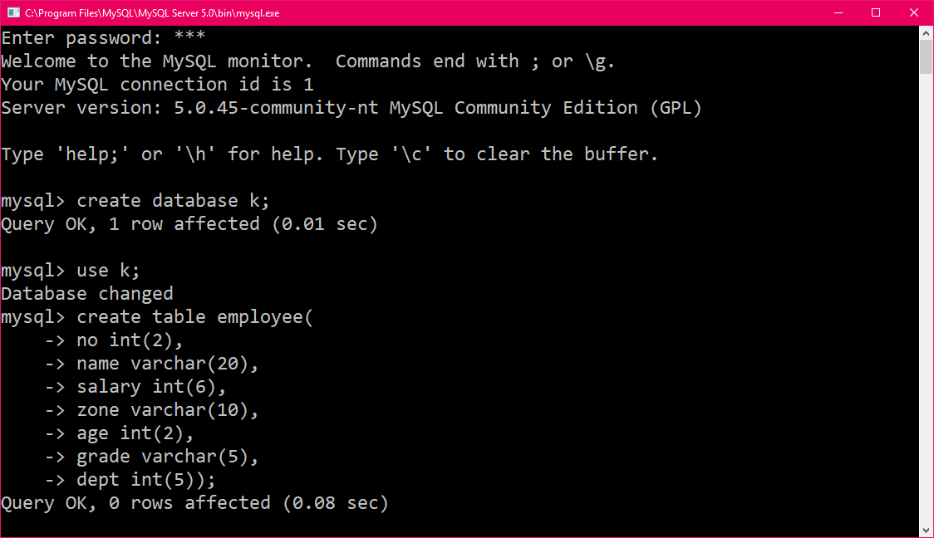

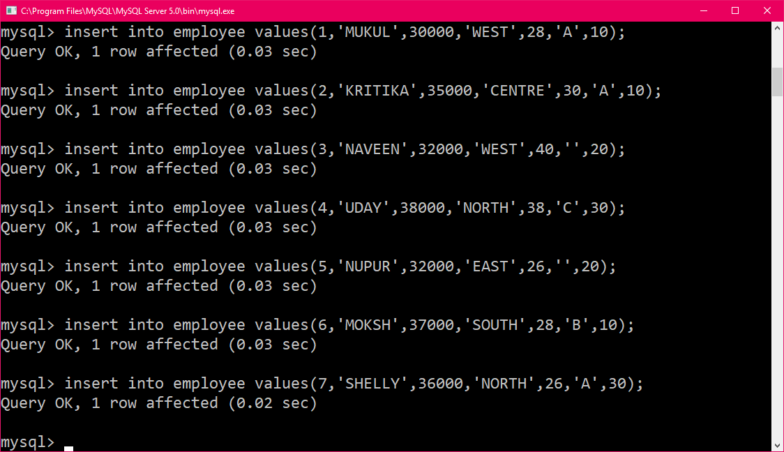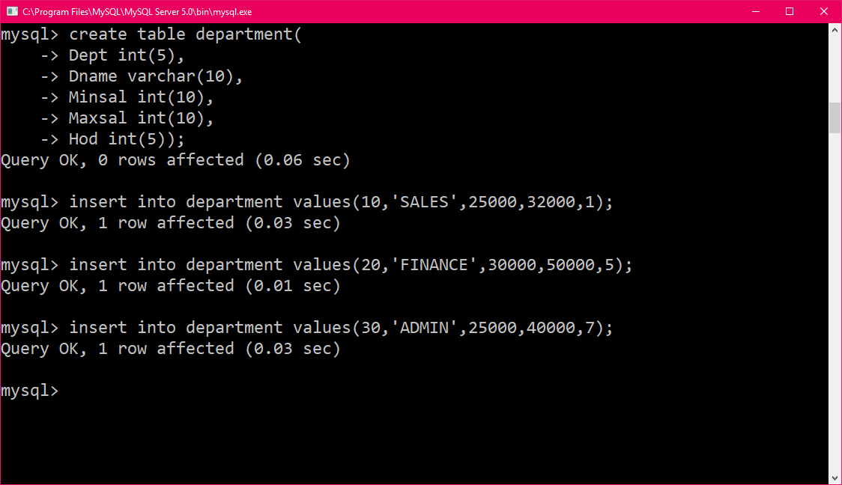

**2:** Display the records of all the employees along with their annual salaries. The salary columnof the table contains monthly salaries of the employees. The new column should be given thename “annual salary”.

select*,salary*12 as 'annual salary' from employee;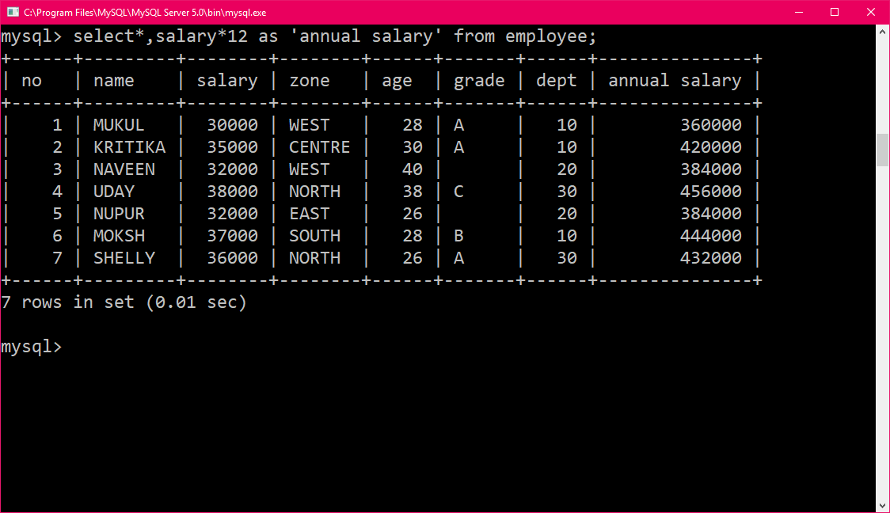

**3:** display the details of all the employees who are below 30 years of age and are working in north zone.

select* from employee where age<30 and zone='NORTH';

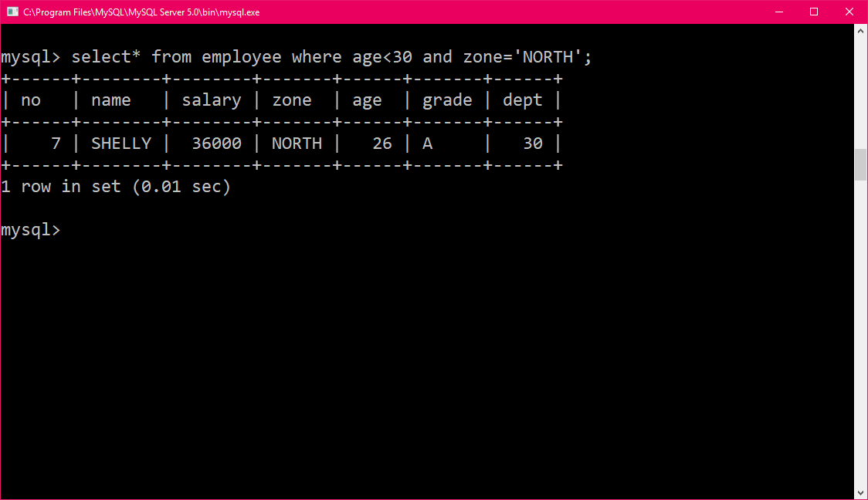

**4:** display the names of various zones from the table employee. A zone name should appearonly once.

select distinct zone from employee;

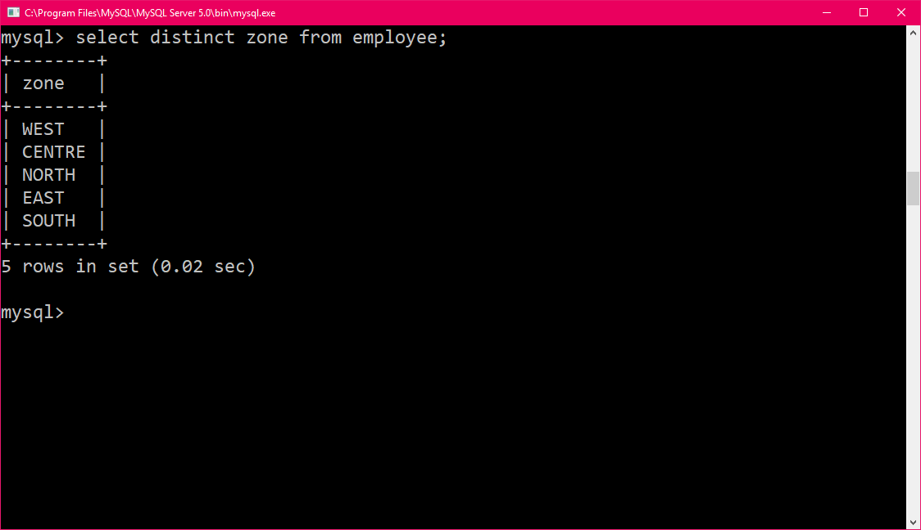

**5.** Display the sum and average of the salaries of all the employees.

select avg(salary),sum(salary) from employee;

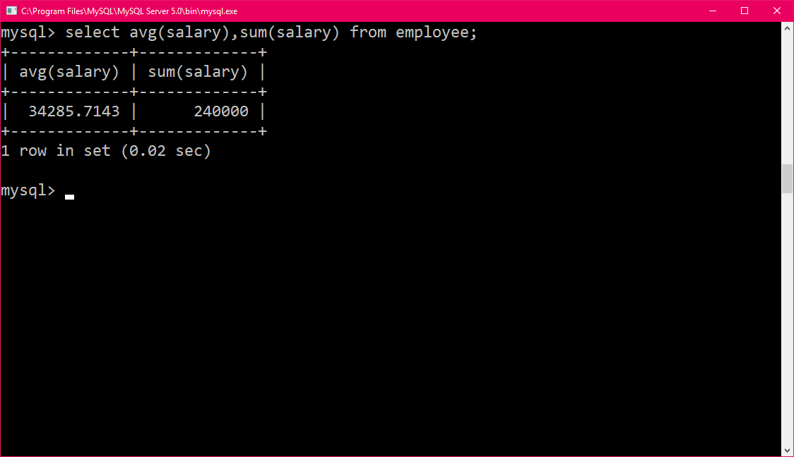

**6.** Display the highest and the lowest salaries being paid in department 10.

select max(salary),min(salary) from employee where dept=10;

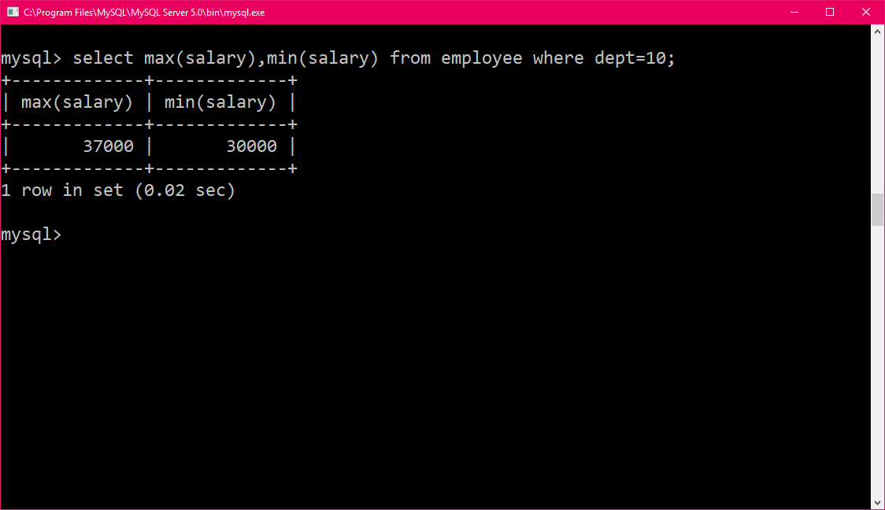

**7.** Display the number of employees working in department 10.

select count(dept) from employee where dept=10;

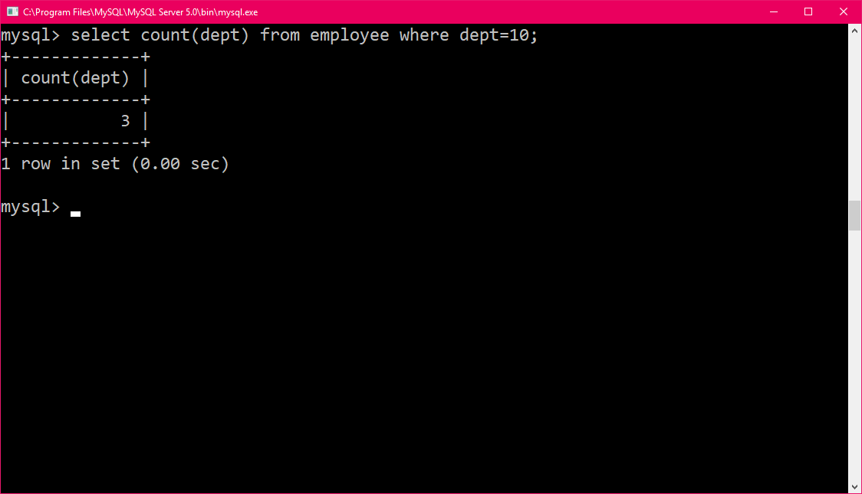

**8.** Display the name, salary, and age of all the employees whose names do not contain ‘a’

select name,salary,age from employee where name not like '%a%';

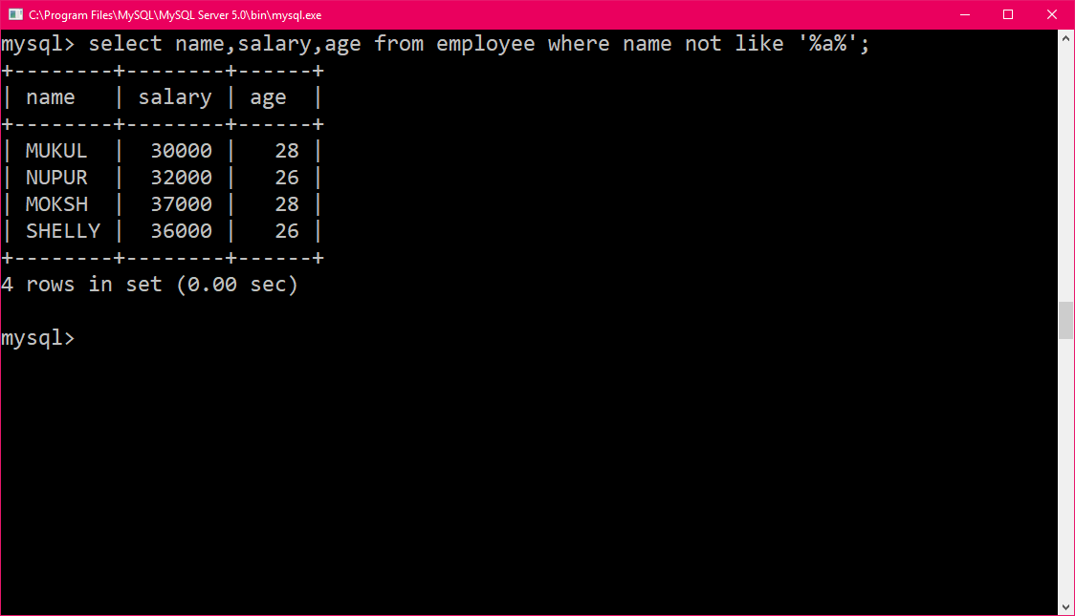

**9.** Display the details of all the employees whose names contain ‘a’ as the second character.

select* from employee where name like '_a%';

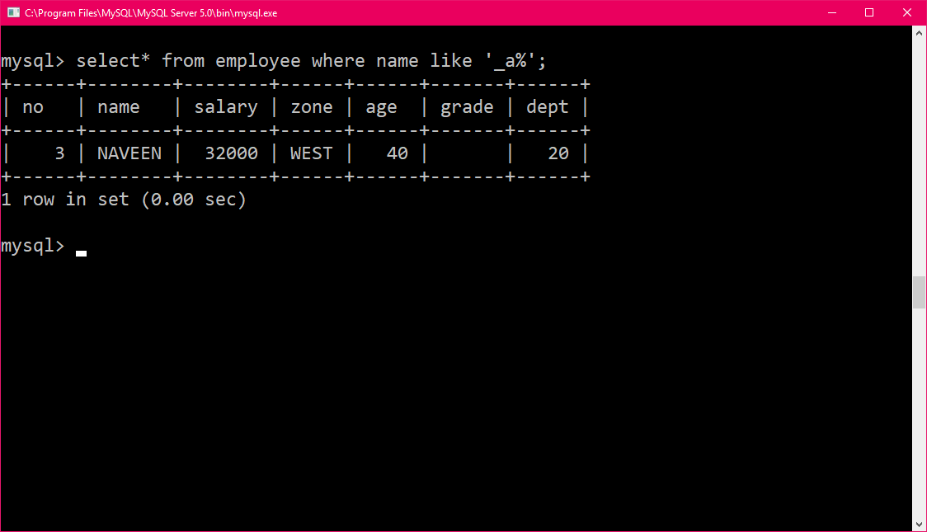

**10.**Display the average age of employees in each department only for those departments inwhich average age is more than 30.

select avg(age),dept from employee group by dept having avg(age)>30;

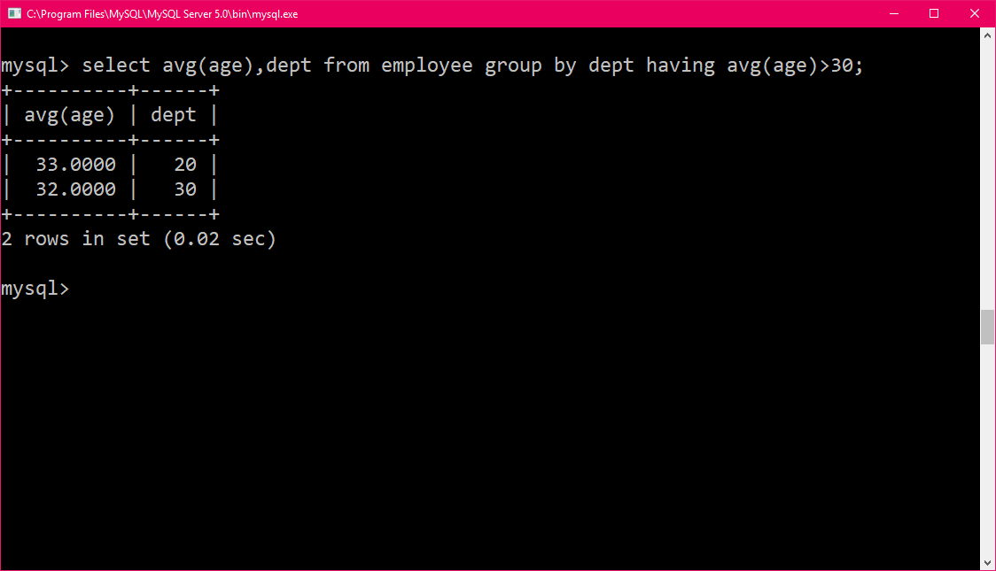

**11.** Display the details of all the employees who work in sales department.

select employee.*,Dname from employee,department where employee.dept=department.dept and Dname='SALES';

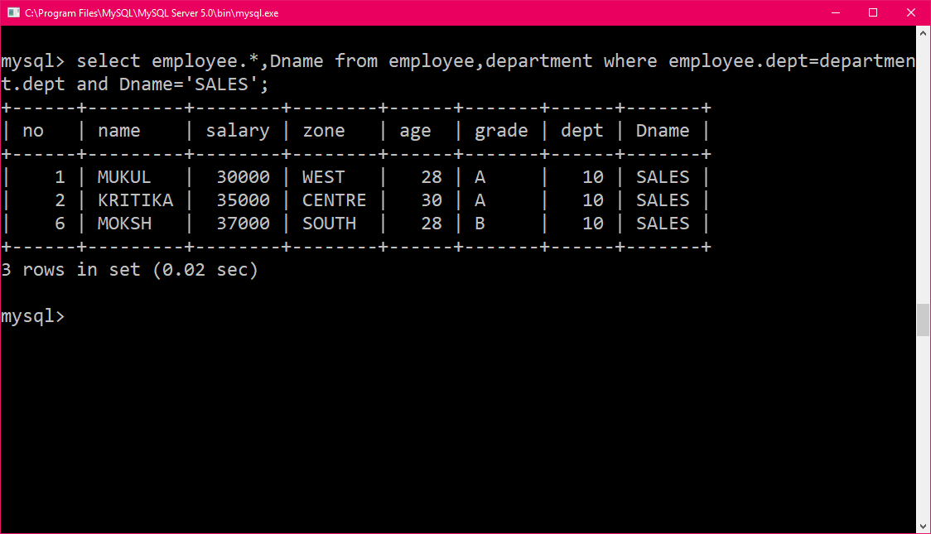

**12.** Display the name and department name of all the employees

select name,Dname from employee,department where employee.dept=department.dept;

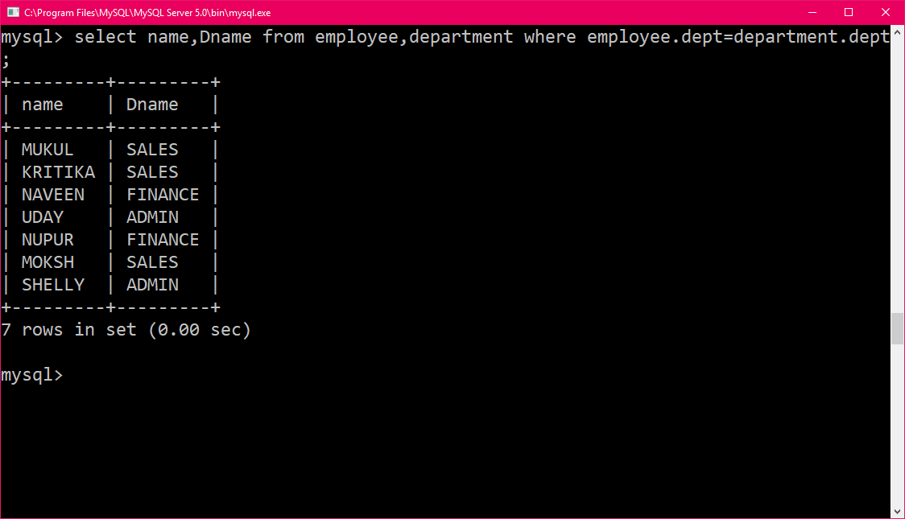

**13.** Display the name of hod of all the departments.

select employee.dept,name from employee,department where employee.no=department.HOD;

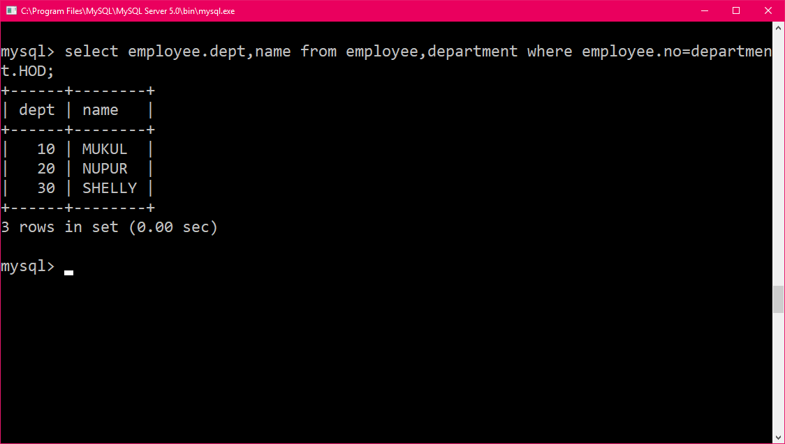

**14.** Display the department name of employee whose name contain ‘h’.

select name,Dname from employee,department where employee.dept=department.dept and employee.name like'%h%';

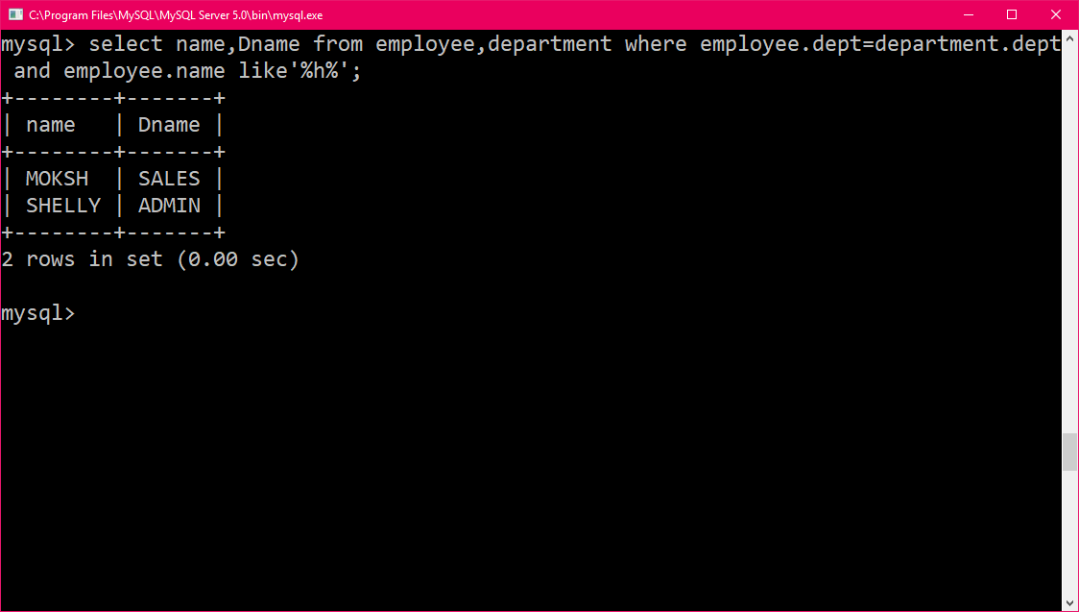

**15.**Put the grade b for all those whose grade is null.

update employee set grade=NULL where grade=' ';

update employee set grade ='B' where grade is null;

select* from employee;

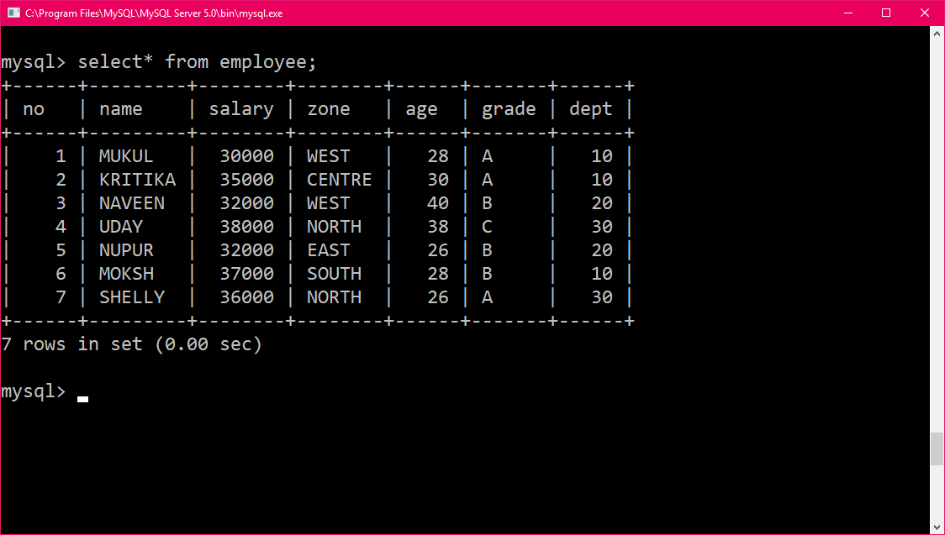

**16.** Increase the salary of all the employees above 30 years of age by 10%.

update employee set salary=(salary*10/100)+salary where age>30;

select* from employee;

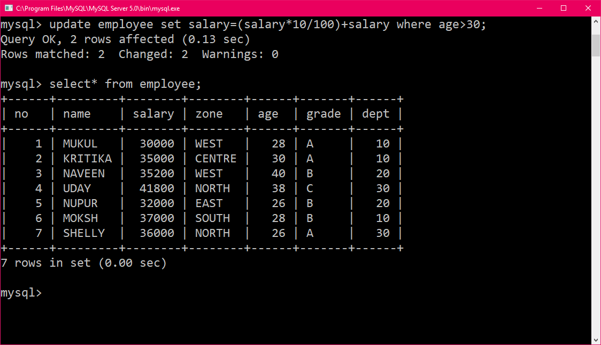

**17.** Delete the records of all the employees whose grade is c and salary is below 30000.

delete from employee where grade='c' and salary<30000;

select*from employee;

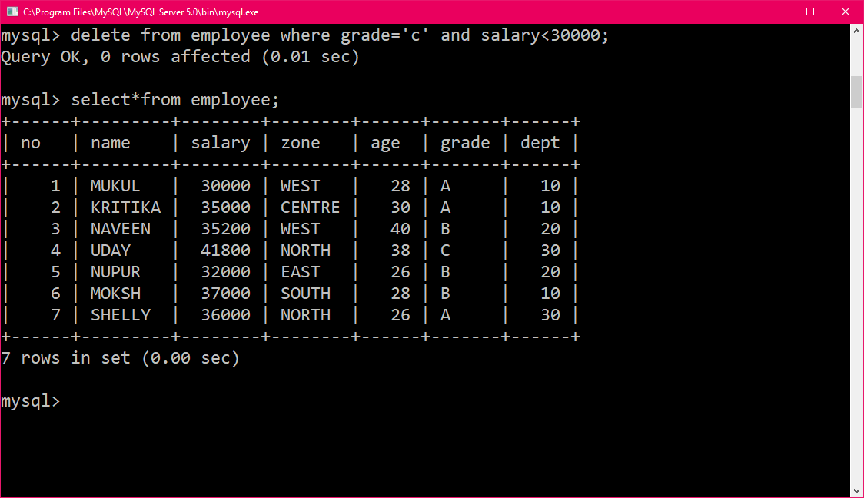

**18.** Add another column hiredate of type date in the employee table.

alter table employee add hiredate date;

select* from employee;

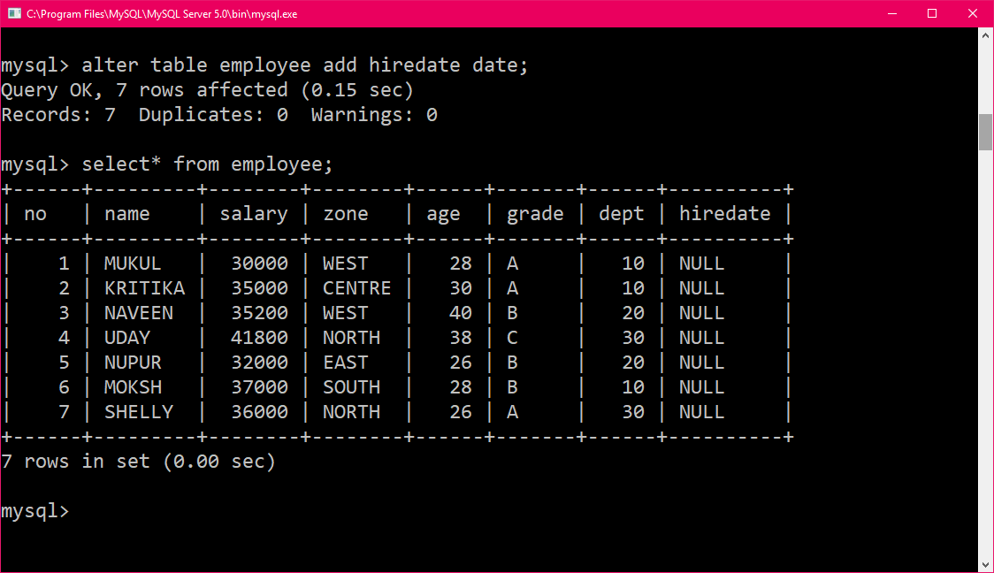

**19.**Delete the data stored in tables employee and department.

delete from employee;

delete from department;

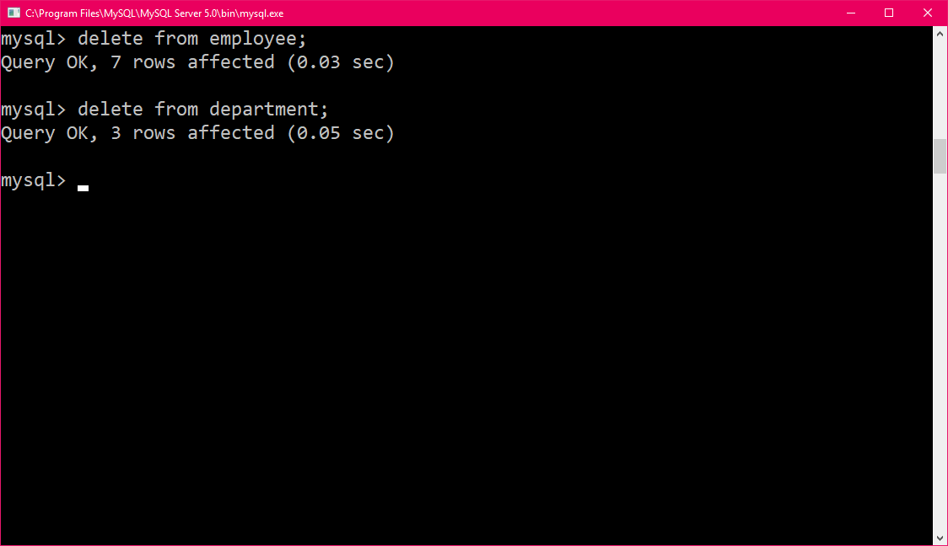

**20.** Drop the tables created above

drop table employee;

drop table department;

